

FACULTY OF INFORMATION AND COMMUNICATION TECHNOLOGY

UCCN2243 Internetworking Principles and Practices

Lecturer: Ts Dr. Gan Ming Lee
Assignment Group Name: Iacnic

No | Group Member | Student ID | Practical Group | Programme
1 | Foo Kar Yeng | 2300422 | P1 | CN
2 | Liew Ren Yi | 2300434 | P1 | CN
3 | Tan Yi Fei | 2200842 | P1 | CN
4 | Wong Pei Kei | 2207466 | P1 | CN

TABLE OF CONTENTS
Question | Contents | Page
1 | - Show the running configurations of Router0 and Router1. Highlight the relevant parts and provide brief explanation. | 1 - 7
 | - Show that PC0, PC1 and PC2 have successfully obtained their IP addresses from the Remote DHCP Server0. Include descriptions. | 8 - 9
 | - Could PC0, PC1 and PC2 DIRECTLY ping the Remote DHCP Server0? Explain WHY / WHY NOT. | 10
2 | - Show (include descriptions) the relevant running configuration for the Edge Router. | 11 - 12
 | - Use Wireshark (integrate it to GNS3) and show (include descriptions) the following:  - PC1 is able to Ping the Internet Gateway and the Telnet Server  - PC2 is unable to Ping the Internet Gateway but able to Ping the Telnet Server  - The relevant NAT occurring in the Wireshark results | 13 - 18
 | - Show the Internet Gateway is able to telnet to the Telnet Server, but unable to Ping to the Telnet Server | 19
 | References | 20 - 21

Question 1
- Show the running configurations of Router0 and Router1. Highlight the relevant parts and provide brief explaination.
Configuration for Router0:
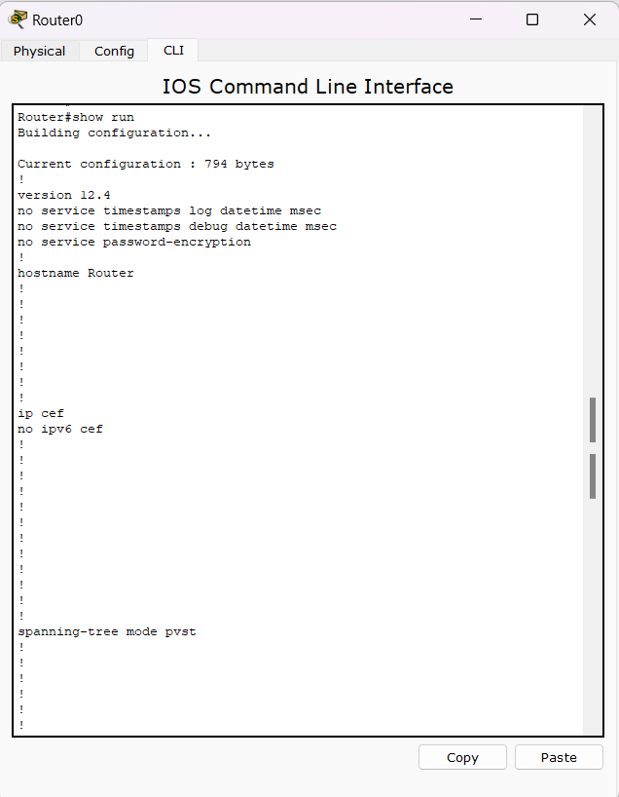
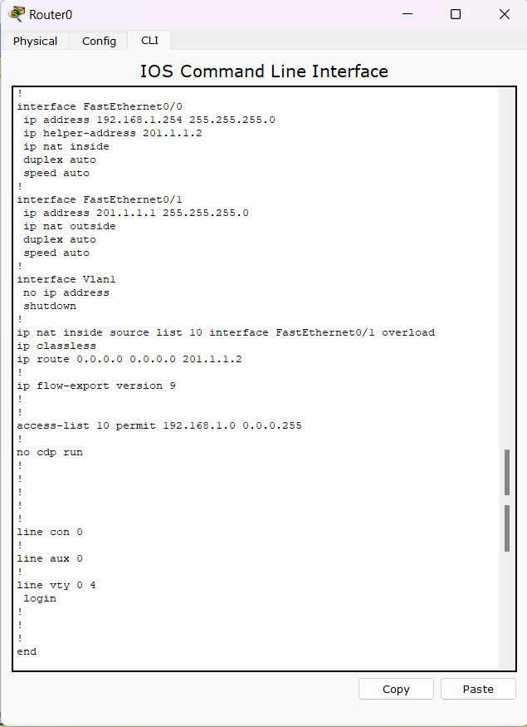
Highlighted relevant parts for Router0:

interface FastEthernet0/0: This command enters the interface configuration mode for the FastEthernet0/0 interface.
ip address 192.168.1.254 255.255.255.0: This command configures the FastEthernet0/0 interface with the IP address 192.168.1.254 and the subnet mask 255.255.255.0.
ip helper-address 201.1.1.2: This command specifies the IP address of the DHCP server (201.1.1.12) that will dynamically assign IP addresses to network hosts [1]. In order to allow devices on the local network to dynamically get IP addresses from the DHCP server, this command is commonly used on routers to enable DHCP requests to be forwarded to a DHCP server located on another subnet.
ip nat inside: This command enables Network Address Translation (NAT) on the interface. The 'inside' keyword indicates that this interface is connected to an internal network (usually a LAN) [2].



interface fa0/1: This command is used to enter the interface configuration mode for the FastEthernet 0/1 interface.

ip address 201.1.1.1 255.255.255.0: This command is used to assign the IP address 201.1.1.1 with a subnet mask of 255.255.255.0 to the FastEthernet 0/1 interface.

ip nat outside: This command is used to set the FastEthernet 0/1 interface for outside NAT translation [2].



ip nat inside source list 10 interface FastEthernet0/1 overload: This command is used to specify an access-list that matches which IPs should be translated. It allows Network Address Translation (NAT) for IP address conservation and configures inside and outside source addresses [3].

ip route 0.0.0.0 0.0.0.0 201.1.1.2: This command configures a default route (also known as a gateway of last resort) to the IP address 201.1.1.2. Any packet that does not match any other route in the routing table is sent to this IP address [4].



access-list 10 permit 192.168.1.0 0.0.0.255: This command configures an access control list (ACL) on a Cisco router. The ACL's number is 10. The permit keyword implies that the regulation will allow traffic. 192.168.1.0 is the network that want to permit. 0.0.0.255 is the wildcard mask for the subnet mask 255.255.255.0[5].

Configuration for Router1:

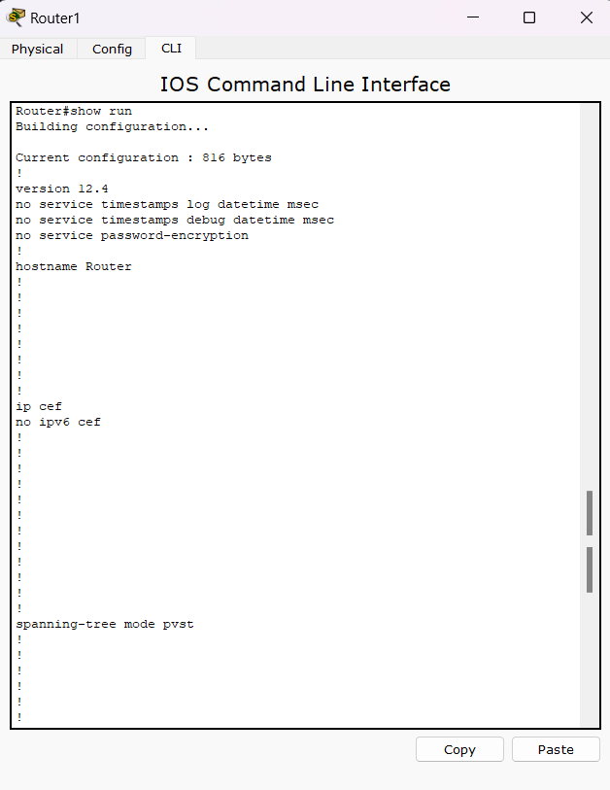
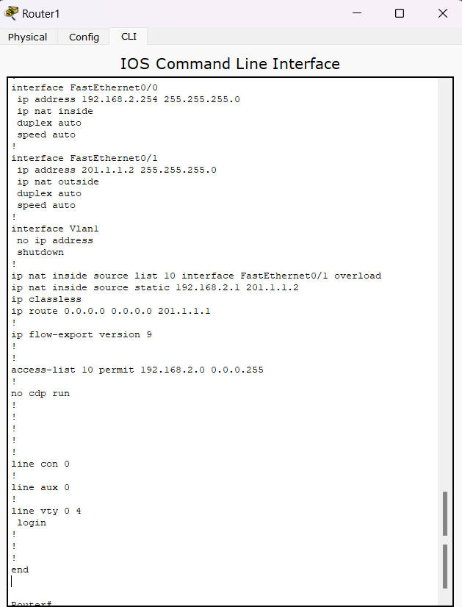
Highlighted relevant parts for Router1:
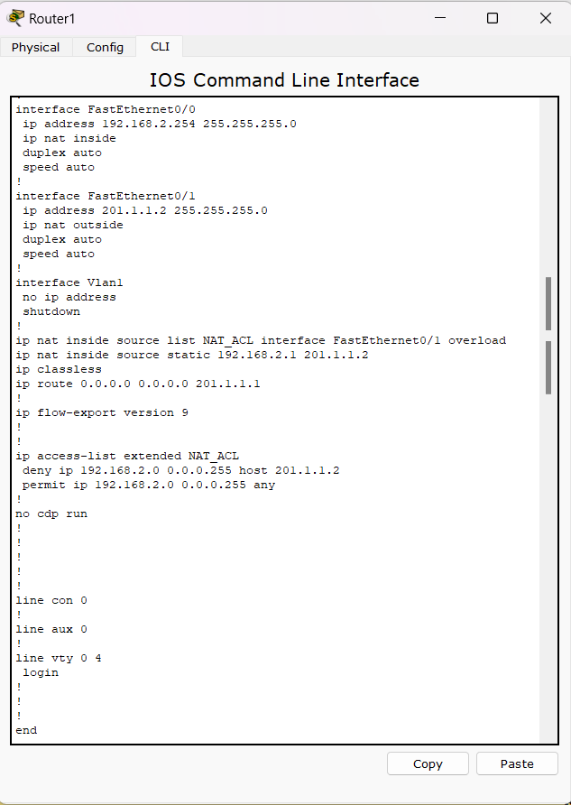
interface FastEthernet0/0: This command enters the interface configuration mode for the FastEthernet0/0 interface.
ip address 192.168.2.254 255.255.255.0: This command configures the FastEthernet0/0 interface with the IP address 192.168.2.254 and the subnet mask 255.255.255.0.
ip nat inside: This command enables Network Address Translation (NAT) on the interface. The 'inside' keyword indicates that this interface is connected to an internal network (usually a LAN) [2].


interface fa0/1: This command is used to enter the interface configuration mode for the FastEthernet 0/1 interface.

ip address 201.1.1.2 255.255.255.0: This command is used to assign the IP address 201.1.1.2 with a subnet mask of 255.255.255.0 to the FastEthernet 0/1 interface.
ip nat outside: This command signifies that the interface is connected to the external network and sets the FastEthernet 0/1 interface for outside NAT translation [2].

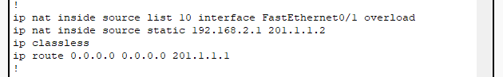
ip nat inside source list 10 interface FastEthernet0/1 overload: This command sets up NAT overload (PAT) on the router, allowing traffic from the internal network (specified by ACL 10) to be translated to the public IP address assigned to interface FastEthernet0/1 when accessing resources on the external network. The overload keyword enables numerous internal devices to be translated to a single IP address [3]. This is commonly used for conserving public IP addresses and facilitating communication from multiple internal devices to the external network.

ip nat inside source static 192.168.2.1 201.1.1.2: This command creates a static translation between an internal local IP address (192.168.2.1) and an external global IP address (201.1.1.2). It is used for mapping a specific internal IP address to a specific external IP address for inbound traffic. This command is used for static one-to-one translations.
ip route 0.0.0.0 0.0.0.0 201.1.1.1: This command creates a default route (sometimes called the gateway of last resort), directing it to the next-hop IP address 201.1.1.1 [4]. It serves to define the next-hop IP address for any traffic not covered by specific routes and is applied by the router when it has to forward packets for destinations outside of its directly connected networks.

access-list 10 permit 192.168.2.0 0.0.0.255: This command configures an access control list (ACL) on a Cisco router. The ACL's number is 10. It accepts any traffic that originates from IP addresses within the network 192.168.2.0/24, ranging from 192.168.2.1 to 192.168.2.254.

- Show that PC0, PC1 and PC2 have successfully obtained their IP addresses from the Remote DHCP Server0. Include descriptions.

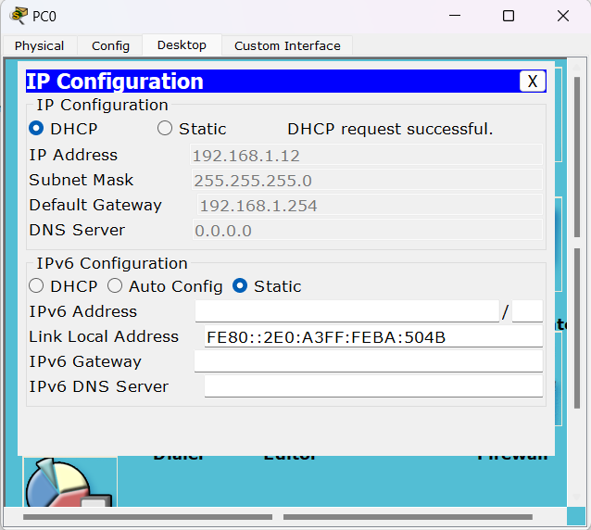
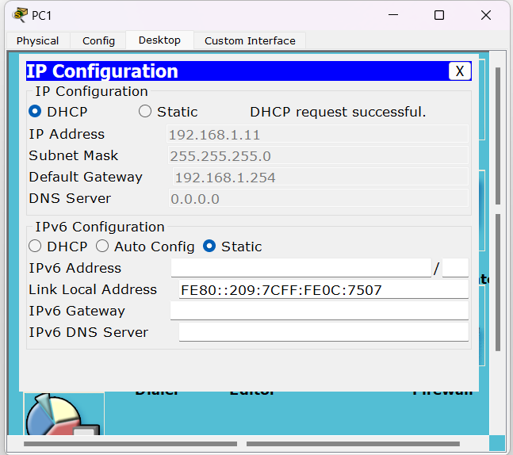
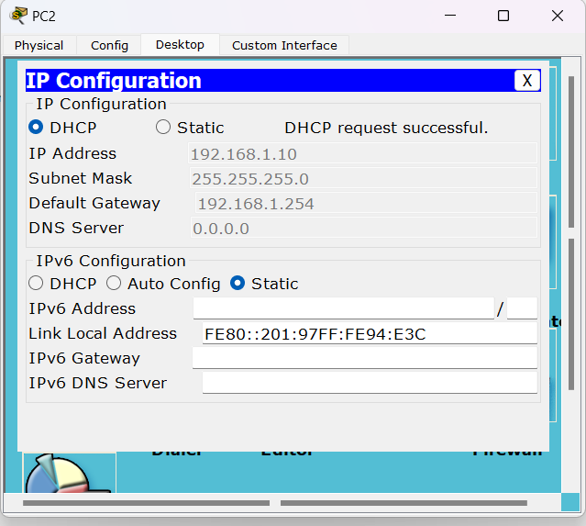
Explanation:
Check the desktop display to discover if PC0, PC1, and PC2 have received an IP address from DHCP server 0. Next, we can implement IP configuration to successfully show the DHCP request. The Internet Protocol (IP) addresses displayed are 192.168.1.10, 192.168.1.11, and 192.168.1.12, with the subnet mask 255.255.255.0. The default gateway is configured to 192.168.1.254, and the DHCP server is identified as 0.0.0.0.

- Could PC0, PC1 and PC2 DIRECTLY ping the Remote DHCP Server0? Explain WHY / WHY NOT.
Answer:
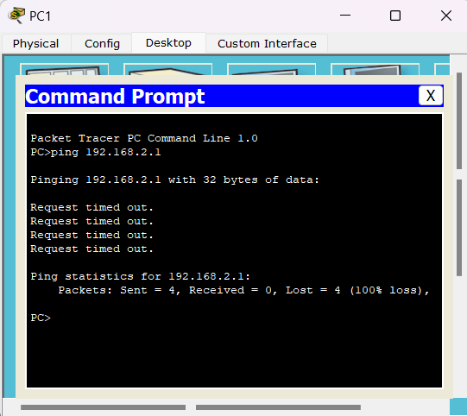
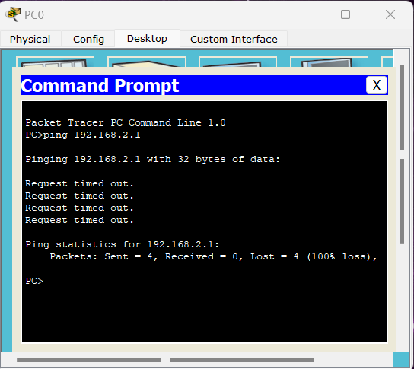
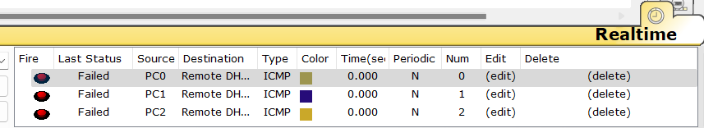
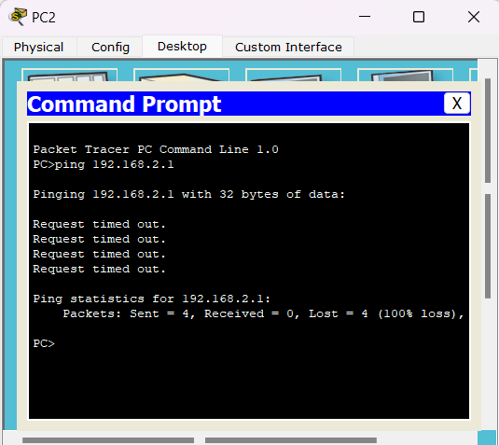
PC0, PC1, and PC2 are unable to directly ping the Remote DHCP Server0. This is primarily due to the lack of an appropriate port forwarding configuration. Port forwarding, a type of static Network Address Translation (NAT), modifies the destination IP address, facilitating communication from an external network to a device within the internal network. However, in the context of DHCP, port forwarding is typically not required. This is because DHCP clients broadcast their requests instead of sending them to a specific IP address. Consequently, to enable DHCP requests to reach a server located on a different network segment, a router must be configured with a DHCP helper (or relay) address. This configuration directs the broadcast requests to the specified server, ensuring successful communication between the DHCP clients and the server.

Question 2
- Show (include descriptions) the relevant running configuration for the Edge Router.
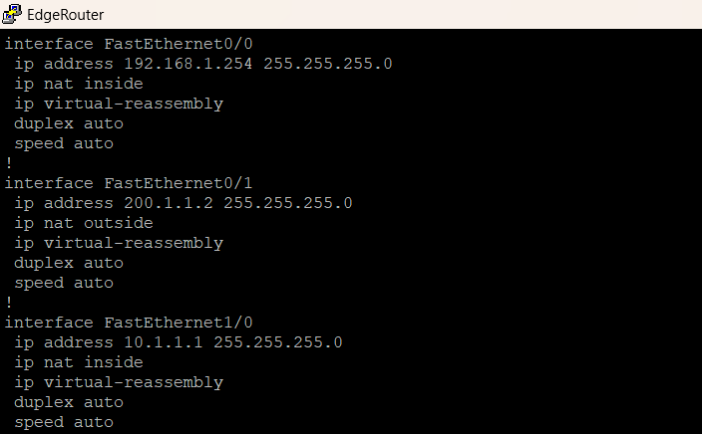
Interface Configuration
The configuration provided sets up an edge router with three interfaces: fa0/0, fa0/1, and fa1/0.
int fa0/0 – Configures interface FastEthernet0/0 with IP address 192.168.1.254 and subnet mask 255.255.255.0. It is designated as an inside interface “ip nat inside”, which defines as private network, primarily employed for NAT (Network Address Translation) purposes [4].
int fa0/1 – Configures interface FastEthernet0/1 with IP address 200.1.1.2 and subnet mask 255.255.255.0, serving as the outside interface “ip nat outside” which defines as public network for NAT.
int fa1/0 – Configures interface FastEthernet1/0 with IP address 10.1.1.1 and subnet mask 255.255.255.0. It is also used inside the network “ip nat inside” as private for NAT translation.
Each interface configuration is augmented with the "no shutdown" command, which is an important step in ensuring the interface is operational allowing traffic to flow through it.
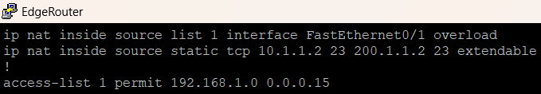
NAT Configuration
access-list 1 permit 192.168.1.0 0.0.0.15
An access control list (ACL) numbered “1” is created to permit traffic from the 192.168.1.0 and subnet mask 0.0.0.15 followed the IP range (192.168.1.1 – 192.168.1.15). This ACL is used for NAT translations.
ip nat inside source list 1 interface fa0/1 overload
NAT is configured to translate the source addresses from the inside network IP range to the IP address of interface fa0/1 (200.1.1.2). This is configured with the “overload” keyword, enabling PAT (Port Address Translation) for handling multiple inside addresses using a single outside address [6].
ip nat inside source static tcp 10.1.1.2 23 200.1.1.2 23
Additionally, a static NAT translation Port Forwarding [7] is configured for TCP traffic destined for port 23 (telnet) from the internal server at private IP address 10.1.1.2 to the public IP address 200.1.1.2 on the same port. This allows external users to access the internal telnet server using the public IP address.

- Use Wireshark (integrate it to GNS3) and show (include descriptions) the following:

- PC1 is able to Ping the Internet Gateway and the Telnet Server
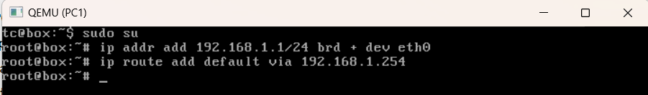
Qemu Image: Microcore PC1 Configuration
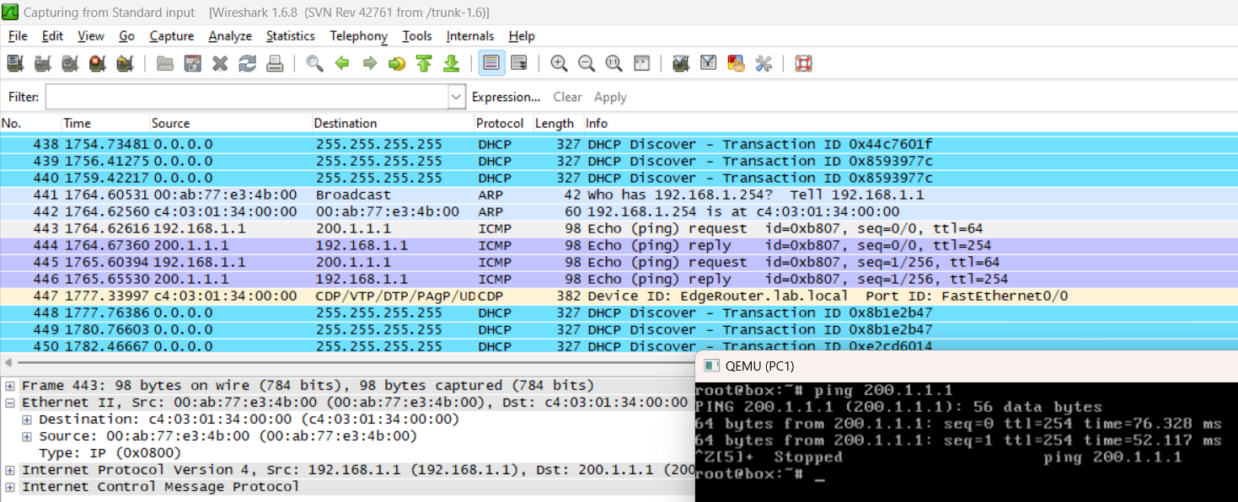
PC1 able to ping Internet Gateway
The Wireshark captures [8] showed ICMP Echo Requests sent from PC1 (192.168.1.1) to the Internet Gateway (200.1.1.1). Following these requests, ICMP Echo Replies are received from both destinations, indicating successful communication. These exchanges illustrate the effective operation of the PAT setup configured from Edge Router, enabling PC1 to access the Internet Gateway, which respond appropriately to PC1's requests.

Telnet Server Static Route Configuration
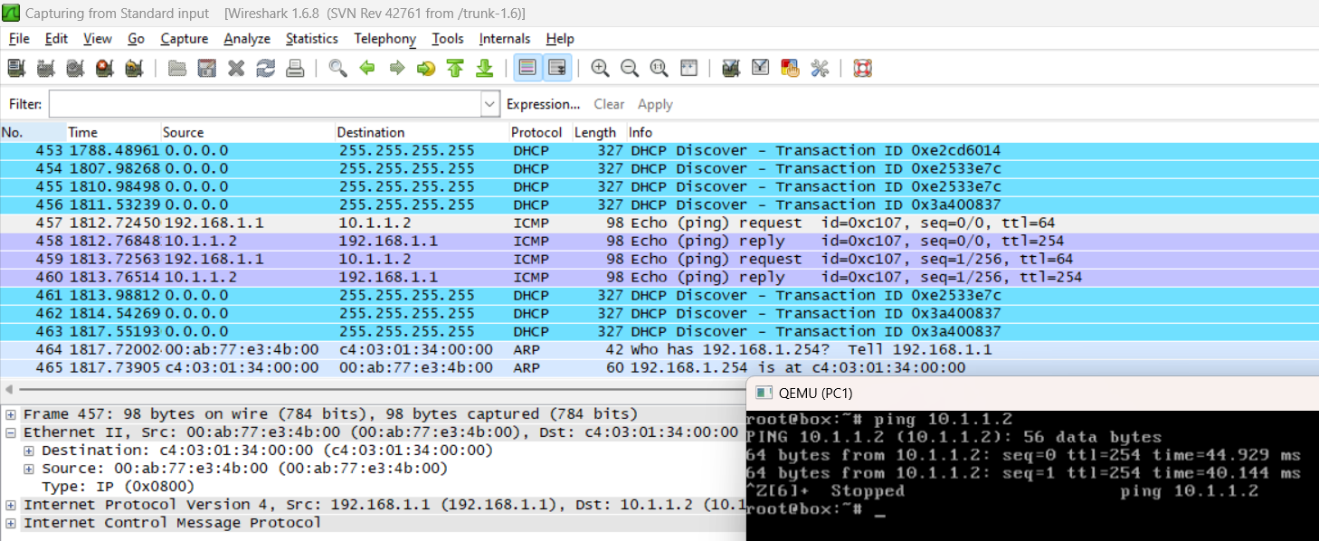
PC1 able to ping Telnet Server
Subsequently, Wireshark capture detected ICMP Echo Requests sent from PC1 (192.168.1.1) to the Telnet Server (10.1.1.2). Both destinations respond with ICMP Echo Replies, indicating successful communication. These interactions highlight the effectiveness of the static route configuration within the routers of the private network, allowing PC1 to reach the Telnet Server.

- PC2 is unable to Ping the Internet Gateway but able to Ping the Telnet Server
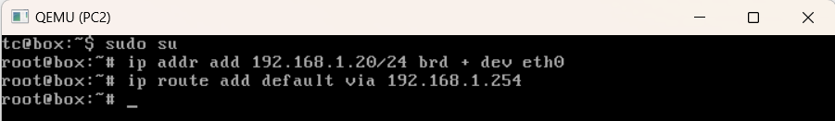
Qemu Image: Microcore PC2 Configuration
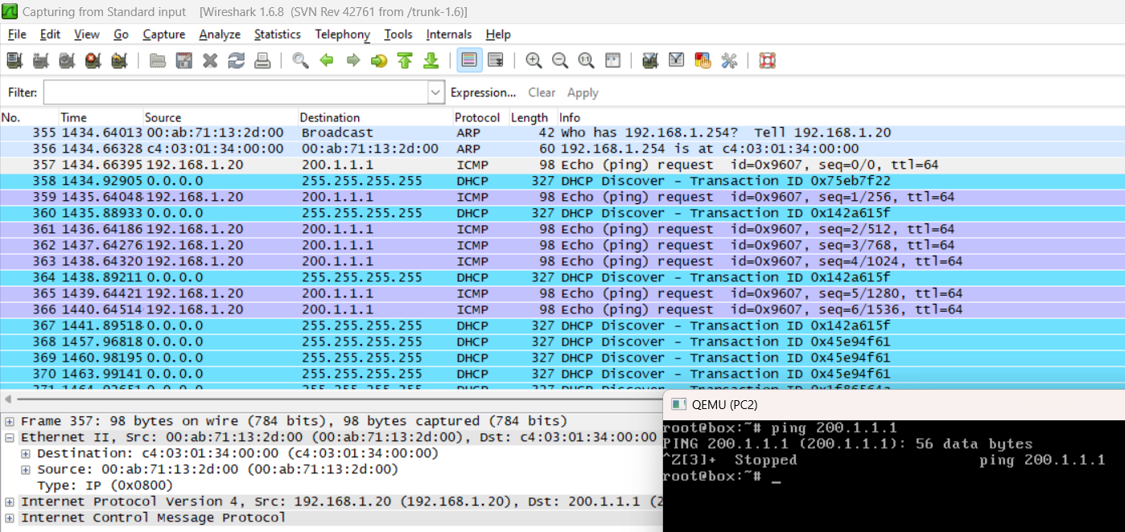
PC2 unable to ping Internet Gateway
PC2’s attempts to communicate with the internet gateway are blocked, as shown by Wireshark data indicating ICMP Echo Requests from PC2 (192.168.1.20) to the internet gateway (200.1.1.1), without corresponding ICMP Echo Replies. It is due to a misconfiguration in the PAT setup on the edge router. Specifically, when PC2 pings the Internet Gateway, the edge router translates PC2's private IP to its public IP. However, because PC2's IP address is not included in the ACL IP range, the translation to the public IP fails.
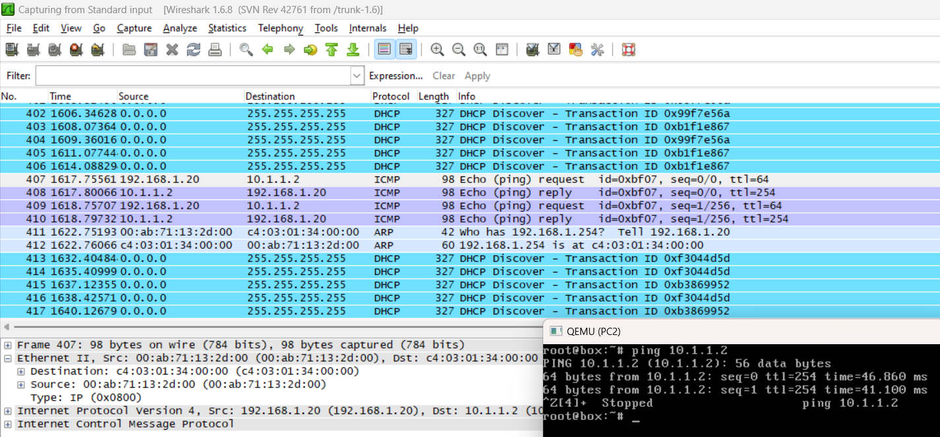
PC2 able to ping Telnet Server
While PC2 maintains successful communication with the Telnet Server (10.1.1.2) located within the private network. The edge router forwards the packet directly without NAT translation, and since the Telnet Server's default gateway is properly set, the response reaches PC2 without any issues.

- The relevant NAT occurring in the Wireshark results
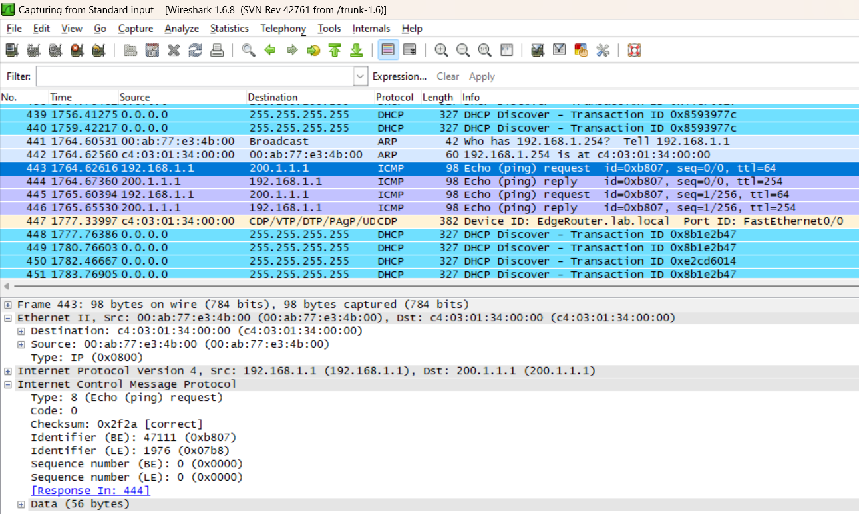
PC1 Ethernet0 Wireshark Encapsulation
In the Wireshark capture on the PC1’s ethernet0 port between PC1 and the Edge Router, the NAT translation process can be observed as packets travel from the local network to the Internet. Initially, packets from PC1 have a source IP (192.168.1.1) and are destined for an IP address on the Internet (200.1.1.1). As these packets traverse the network, they encounter the Edge Router's interface fa0/1. Here, the Edge Router performs NAT, replacing the source private IP with its public IP address (200.1.1.2).
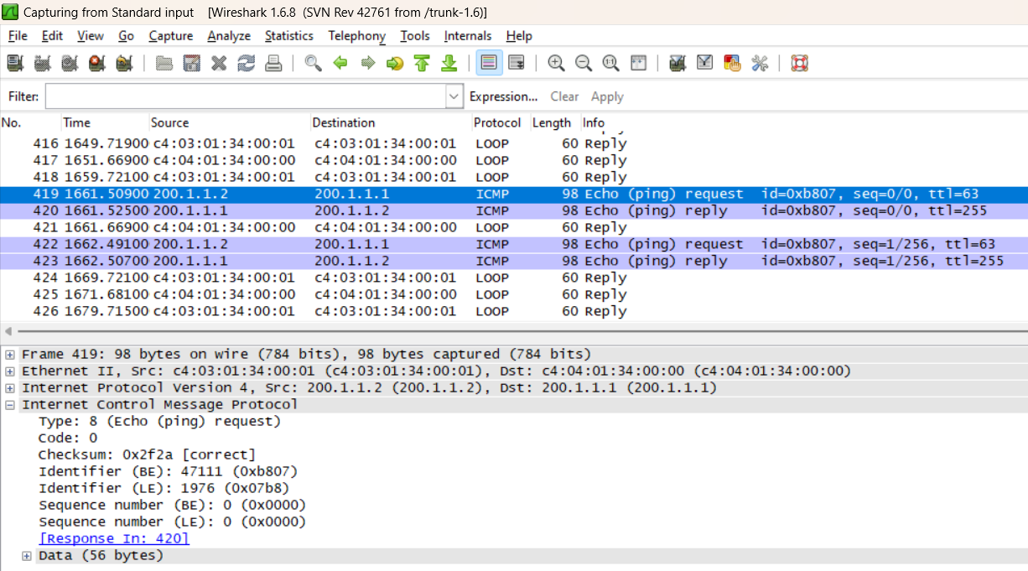
Edge Router FastEthernet0/1 Wireshark Encapsulation
In the capture on the Edge Router's interface fa0/1 between Edge Router and Internet Gateway, the source IP (192.168.1.1) of the packets are now changed to public IP (200.1.1.2), while the destination IP (200.1.1.1) remains unchanged as the Internet Gateway.
Similarly, inbound traffic from the Internet to PC1 shows NAT translations, where the destination IP is translated from the Edge Router's public IP (200.1.1.2) to PC1's private IP (192.168.1.1). These NAT translations enable communication between PC1 and the Internet while hiding the private IP addresses from public networks. They can be identified by comparing the source and destination IP addresses and their ID between the two captures [9].

- Show the Internet Gateway is able to telnet to the Telnet Server, but unable to Ping to the Telnet Server.
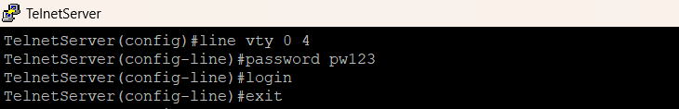
Telnet Server Configuration
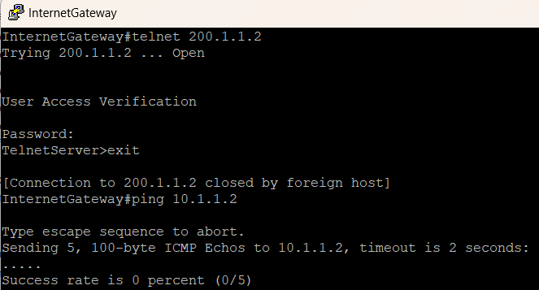
Internet Gateway able to telnet to the Telnet Server Public IP

Internet Gateway unable to ping to the Telnet Server private IP
The Internet Gateway can telnet to the Telnet Server due to static NAT translation Port Forwarding, allowing external users to access the internal server using the public IP address. However, the Internet Gateway cannot ping the server because ICMP traffic isn't explicitly forwarded by the NAT configuration.

References
[1] Andrea, H. (2023, April 13). All About the “ip helper-address” Command on Cisco –
Configuration and Explanation. Networks Training. https://www.networkstraining.com/ip-
helper-address-command/
[2] Configure Network Address Translation. (2023, November 3). Cisco.
https://www.cisco.com/c/en/us/support/docs/ip/network-address-translation-nat/13772-
12.html
[3] Configuring NAT for IP Address Conservation. (2022, July 5). Cisco.
https://www.cisco.com/c/en/us/td/docs/ios-xml/ios/ipaddr_nat/configuration/xe-16/nat-xe-
16-book/iadnat-addr-consv.html
[4] U. (2022, December 18). Default static route. Study CCNA. https://study-ccna.com/default-
static-route/
[5] Configure and Filter IP Access Lists. (2024, February 13). Cisco.
https://www.cisco.com/c/en/us/support/docs/security/ios-firewall/23602-confaccesslists.
html
‌[6] What is the use of NAT and PAT?. Educative. https://www.educative.io/answers/what-is-the-
use-of-nat-and-pat.
[7] Configuring Network Address Translation and Static Port Address Translation to Support
an Internal Web Server. Cisco. https://www.cisco.com/c/en/us/support/docs/long-reach-
ethernet-lre-digital-subscriber-line-xdsl/asymmetric-digital-subscriber-line-adsl/12905-
827spat.html
[8] Meena. How to use WireShark in GNS3? A Step-by-step Demonstration - luminisindia.com.
luminisindia.com. https://luminisindia.com/it-networking-blog/162-how-to-use-wireshark-
in-gns3-a-step-by-step-demonstration

[9] WIRESHARK NAT SN 10500724. www.youtube.com.https://www.youtube.com/watch? v
=BmUYTNwwL3o

